Project Design Phase-II
Data Flow Diagram & User Stories

Date | 31 January 2026
Team ID
Project Name | EV Market Analysis (Tableau)
Maximum Marks | 4 Marks

Data Flow Diagrams:
A Data Flow Diagram (DFD) is a traditional visual representation of the information flows within a system. A neat and clear DFD can depict the right amount of the system requirement graphically. It shows how data enters and leaves the system, what changes the information, and where data is stored.
DFD Symbol Legend
Symbol | Name | Description
Oval / Rounded  shape | External Entity | A person, organization, or system outside the project that sends or receives data (e.g., Customer, Payment Gateway).
Rectangle with  numbered header | Process | An activity that transforms incoming data into outgoing data (e.g., Validate Request, Process Order).
Rectangle (solid fill, no number) | Data Store | A place where data is held for later use (e.g., Customer Database, Inventory).
Labeled arrow | Data Flow | The movement of data between entities, processes, and data stores, labeled with what data is being passed.

Example: DFD Level 0 (Industry Standard)



Level 1 DFD: EV Market Analysis Project
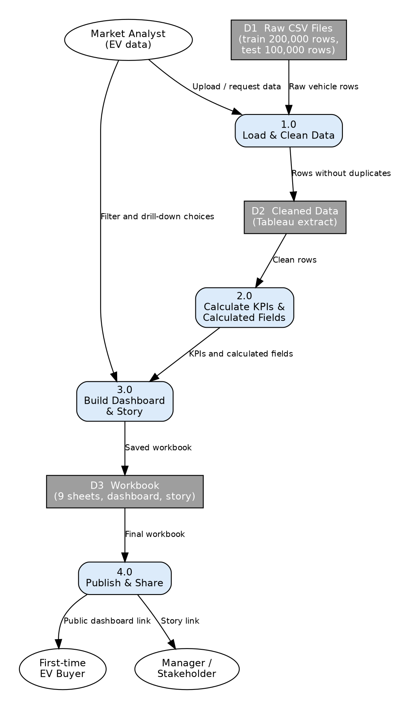
User Stories
Use the below template to list all the user stories for the product.
User Type | Functional Requirement (Epic) | User Story Number | User Story / Task | Acceptance criteria | Priority | Release
Market Analyst | Data Access & Preparation | USN-1 | As an analyst, I can load ev_market_train.csv into Tableau so that I can analyze all vehicles. | Data source connects and row count shows 200,000 (before duplicate removal). | High | Sprint-1
 |  | USN-2 | As an analyst, I can remove the duplicate row so that counts and sums are accurate. | Cleaned file has 199,999 rows and no duplicate vehicle_id. | High | Sprint-1
 |  | USN-3 | As an analyst, I can see null counts for key columns so that I know which averages to trust. | Null summary shows counts for resale_value, customer_rating, battery_cycle_life, annual_sales_units. | Medium | Sprint-1
 | Market Dashboard | USN-4 | As an analyst, I can view KPI cards for total vehicles, total sales, average price, average range, and average rating. | KPI values change correctly when a filter is applied. | High | Sprint-2
 |  | USN-5 | As an analyst, I can see the top 10 manufacturers by annual sales. | Bars are sorted from highest to lowest sales. | High | Sprint-2
 |  | USN-6 | As an analyst, I can see regional market share. | Shares add up to 100%. | High | Sprint-2
 | Product & Battery Analysis | USN-7 | As an analyst, I can compare battery degradation by battery type. | Bar chart shows average degradation for each battery type. | Medium | Sprint-2
 |  | USN-8 | As an analyst, I can see price vs range by category. | Scatter plot tooltip shows category, price, and range. | Medium | Sprint-2
 |  | USN-9 | As an analyst, I can see how charging speed relates to charging band. | Fast, Medium, and Slow bands show average charging time. | Medium | Sprint-3
 |  | USN-10 | As an analyst, I can see price and range trends from 2018 to 2026. | Line chart covers all model years 2018 to 2026. | Medium | Sprint-3
 | Filters & Interaction | USN-11 | As an analyst, I can filter by region, category, and model year across all sheets. | Filter applies to every worksheet in the dashboard. | High | Sprint-2
 |  | USN-12 | As an analyst, I can click a manufacturer and have the other sheets update. | Use as Filter works on the Manufacturer sheet. | Medium | Sprint-2
 | Story & Publishing | USN-13 | As an analyst, I can build a 5-point story explaining the market. | Story has 5 points, each with a 1 to 2 line caption. | Medium | Sprint-3
 |  | USN-14 | As an analyst, I can publish the dashboard to Tableau Public and share the link. | Link opens in a private browser window. | High | Sprint-3
First-time EV Buyer (Web user) | Vehicle Comparison | USN-15 | As a first-time buyer, I can compare range, price, and charging time for two categories. | Comparison view shows both categories side by side. | Medium | Sprint-3
 |  | USN-16 | As a buyer, I can see recommended use cases (city, family, long-distance). | Use case list matches recommended_use_case in the data. | Low | Sprint-3
Manager (Stakeholder) | Access & Reporting | USN-17 | As a manager, I can open the dashboard from a link without installing Tableau. | Dashboard opens in a web browser. | High | Sprint-3
 |  | USN-18 | As a manager, I can read the story to understand the key insights in under 5 minutes. | Story has the 5 points and key insights are clear. | Medium | Sprint-3
Project Admin | Project Maintenance | USN-19 | As the project admin, I can keep the GitHub repo updated with data, screenshots, and README. | Repo has the latest CSV, screenshots, and README with the Tableau link. | Low | Sprint-3

